Tax strategy for the VKR Group

Adopted and approved by the Board of Directors of DOVISTA UK LTD. at an extraordinary meeting on 22 august 2024, for the financial year ending on 31 December 2024

The VKR Group manufactures and sells its products through its Business Areas: Roof windows & skylights and Vertical windows in over 40 countries and is organized under VKR Holding A/S as the Group’s ultimate parent company. Each Business Area has its own legal structure and consists of several underlying Companies.
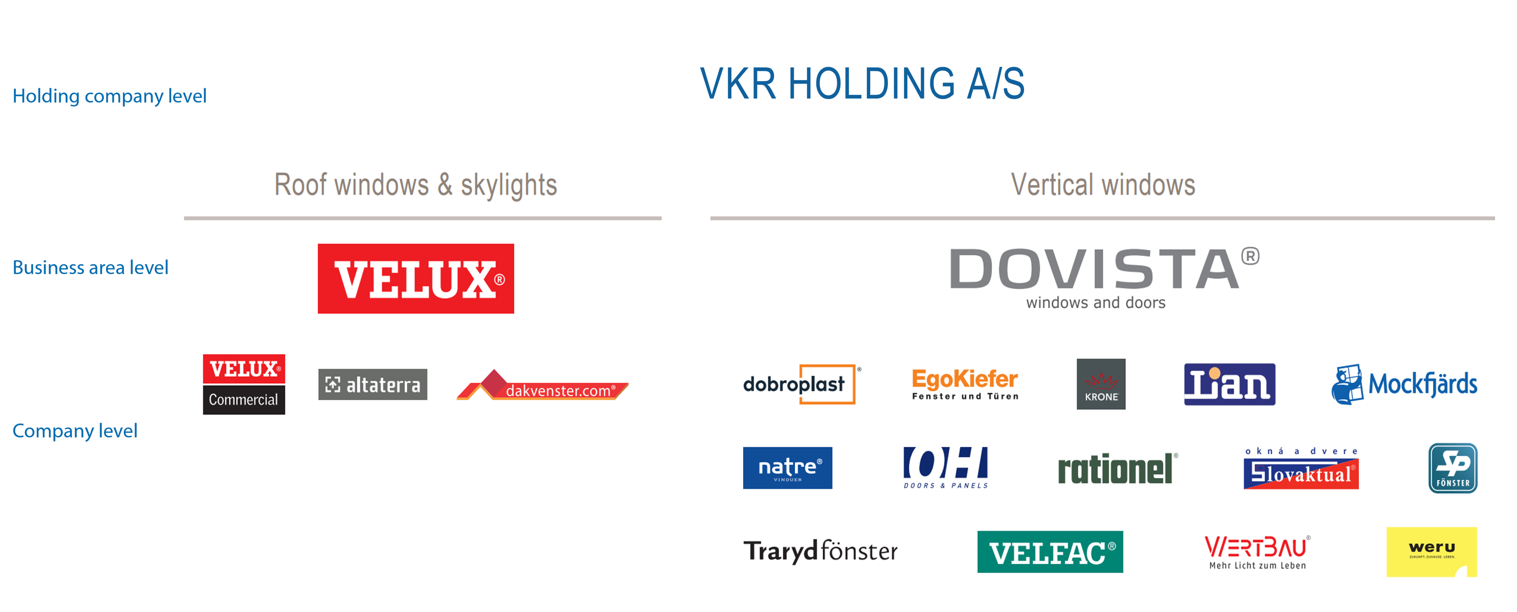
Our mission is to “improve people’s lives by bringing daylight, fresh air and a better environment into their everyday lives”.

Our shareholders stated already in 1965:

The purpose of the VKR Group is to establish a number of model
companies, which cooperate in an exemplary manner.
A model company works with products useful to society
and treats its customers, suppliers, employees of all categories
and shareholders better than most other companies.
A model company makes a profit which can also finance growth
and maintain financial independence

Our tax strategy and approach to tax is built on the same foundation, a commitment to be a good corporate citizen, whilst being conscious of the need for profitability.

The following statement of our tax strategy is aimed at meeting the requirements set out in paragraph 19(2) Schedule 19, Finance Act 2016. The tax strategy applies generally to the entire VKR Group.

Approach of the business to tax risk management and governance
The VKR Group, when preparing tax returns, aims to respecting both the wording and the spirit of the legislation.

When a transaction is changed or a new transaction is contemplated, or if relevant laws change, we aim at evaluating any effect and tax risk associated with the change. We maintain in-house tax expertise and ensure that relevant staff is sufficiently trained to either determine the appropriate tax treatment or to identify when external advice is required.

The Board of Directors of VKR Holding A/S is informed about tax, including tax risks, in its four annual meetings. The Boards of Directors in each of the Business Areas owned by VKR Holding A/S are informed about tax risks and other tax developments annually. In addition, should a tax risk arise in-between such meetings the risk is communicated by the tax department to the Management of the Company or Business Area, which in turn informs the Business Area’s audit committee and/or Board of Directors.

The VKR Group seeks to ensure that day-to-day flows of transactions between Group Companies are governed by guidelines or automated processes laid down in ERP systems. Staff in functions appointed to implement changes to the business transactions are aware of the need for contacting the tax department for approval.

New legislation is monitored by close contact to external advisors providing updates of tax laws in countries of significant importance for the VKR Group.

Level of Risk Prepared to Accept
Tax is complex. It involves detailed legislation, different in each country, as well as international law, regulations and guidelines. It is inevitable that the tax effects of business transactions entail some level of risk that the tax authorities may take a different view than the taxpayer. Furthermore, tax authorities in different jurisdictions might disagree, implying a risk for the VKR Group.

The VKR Group is committed to properly reflect the tax effects of its commercial reality in the tax it pays. We do not accept risk that could have more than a low impact on our payable tax. Where the involved amounts and complexity of the involved regulations or facts are significant, we obtain expert advice on the level of risk and the ways to manage and reduce it. We also, where appropriate, seek clarification through open and honest communication with the tax authorities.

Attitude of the business towards tax planning
Business in the VKR Group is driven by the commercial rationale. However, in a complex legislative environment, it is necessary for businesses to plan ordinary business changes or transactions to avoid unintended tax consequences, such as double taxation. We do consider the tax consequences of commercial transactions and we do claim relevant allowances and incentives. We do not engage in artificial non-business driven planning of transactions or business structures solely for the purpose of reducing tax.

Approach towards dealing with tax authorities
The VKR Group’s approach towards dealing with tax authorities is that appropriate communication must be timely, honest and open. If relevant we seek clarification of uncertainties in dialogue with the relevant tax authorities. We are committed to ensuring correct payment of tax by seeking to amend any mistakes in tax returns discovered even after their filing.

We respect the expertise held by tax authorities’ officials in all matters related to tax but reserve the right to disagree with the interpretation of laws and guidelines. In such cases, we seek clarification of the disagreement by way of the legitimate means.

